Interactive Circulatory System
Kensho Gendzwill  Bioengineering  kenshog@uw.edu  Section AA | Benjamin Han  Bioengineering  bhan830@uw.edu  Section AB | Yuki Kuo  Bioengineering  yutzukuo@uw.edu  Section AC | Vicky Yeh  Bioengineering  shuyiyeh@uw.edu  Section AC

Link to our project

https://observablehq.com/d/436687aff3067647

Introduction
Our project aims to illustrate the cardiovascular system of the human body and the different heart problems associated with it. There will be two different aspects of our project: Visual diagrams detailing information about different heart diseases, and interactive charts about heart diseases in general. We intend to make the project interactive by allowing the user to click on different labels in the diagram and select different parameters to read about their causes, epidemiology, impact by demographics, financial costs, complication data, and other useful information in our separate charts. So far for this milestone, we have examples of what data we want to display and what information we want to provide for the diagrams.

Datasets
In the prototype of the final project, we only utilized the first two datasets to create interactive visualizations. However, the third and fourth datasets contain additional information for cardiovascular statistical data, such as the risk factors of different circulatory system diseases, but they are not specifically based on overall heart diseases like the datasets we currently used. We are currently facing challenges in loading such large files onto Observable. If we can successfully integrate these datasets into our project, we can provide a more comprehensive overview of heart diseases.
- https://www.cdc.gov/nchs/pressroom/sosmap/heart_disease_mortality/heart_disease.htm
This dataset includes the mortality rate and the number of deaths of heart disease by state from 2005 to 2021. The data is sourced from CDC/National Center for Health Statistics.
- https://catalog.data.gov/dataset/rates-and-trends-in-heart-disease-and-stroke-mortality-among-us-adults-35-by-county-a-2000-45659
This dataset shows the heart disease information for different counties and states. It includes location information, gender, race/ethnicity, and miscellaneous metadata. This data has higher quality, as it comes from the National Vital Statistics System, and was put forth by the US Department of Health and Human Services.
- https://catalog.data.gov/dataset/behavioral-risk-factor-surveillance-system-brfss-national-cardiovascular-disease-surveilla
This dataset organizes national trends in cardiovascular disease by risk factor. The data are credible because it comes from the USDHHS.
- https://catalog.data.gov/dataset/heart-disease-mortality-data-among-us-adults-35-by-state-territory-and-county-2018-2020-3a2b0
This dataset describes trends in mortalities from 2018-2020 that resulted from cardiovascular disease. The data are credible because it comes from the USDHHS.
Interactive Visualizations
Visualization 1- Main Diagram

This visualization below shows a human body and a detailed heart image. The body has the cardiovascular system highlighted, and the heart image has arrows indicating the direction of blood flow. In both pictures, there are different labels for heart-related health conditions located relative to where they affect the heart and body. When clicked on by the user, it will display a variety of data and information regarding the condition of interest.
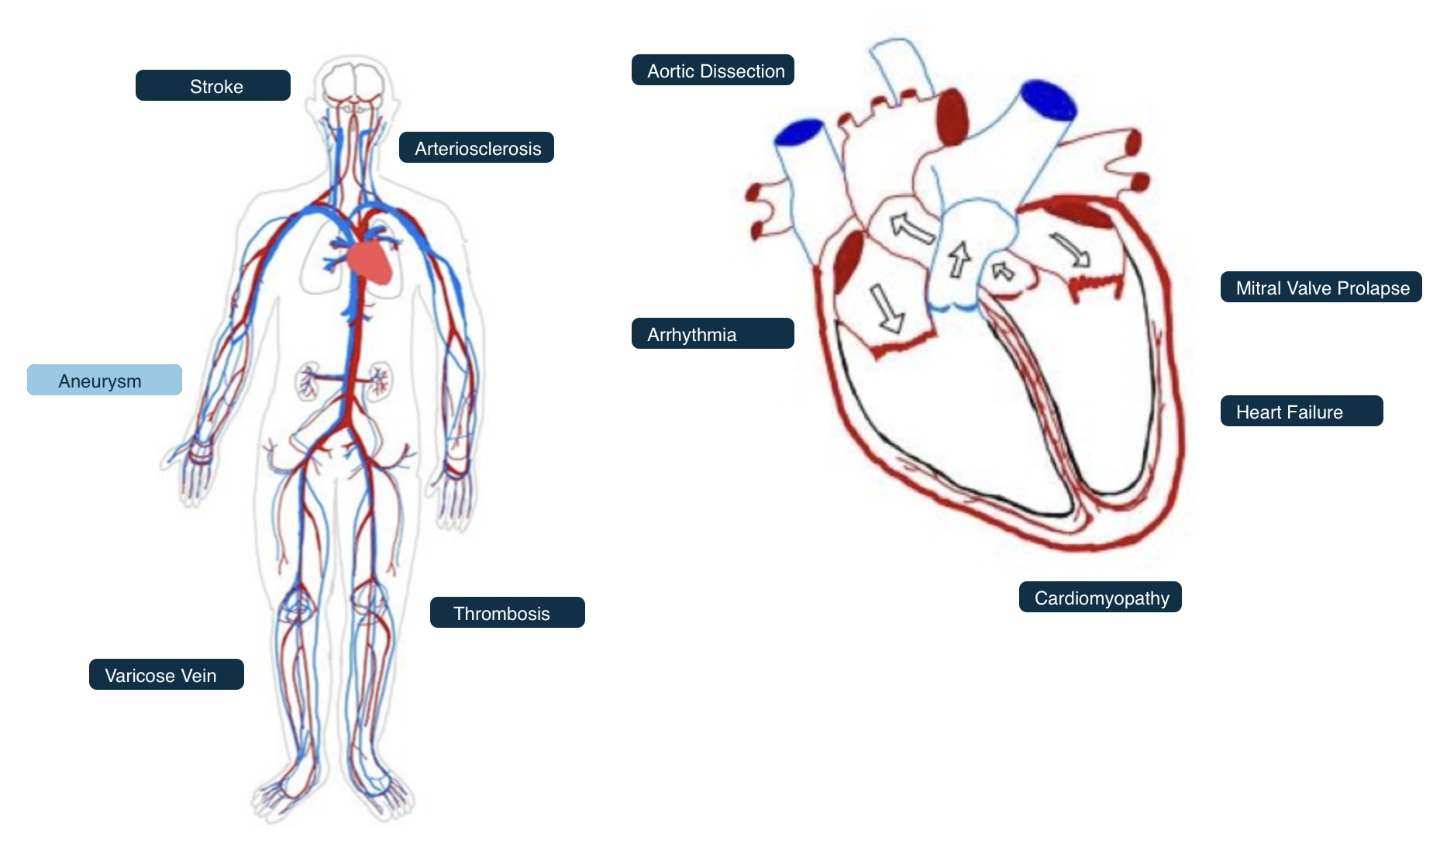
⬇
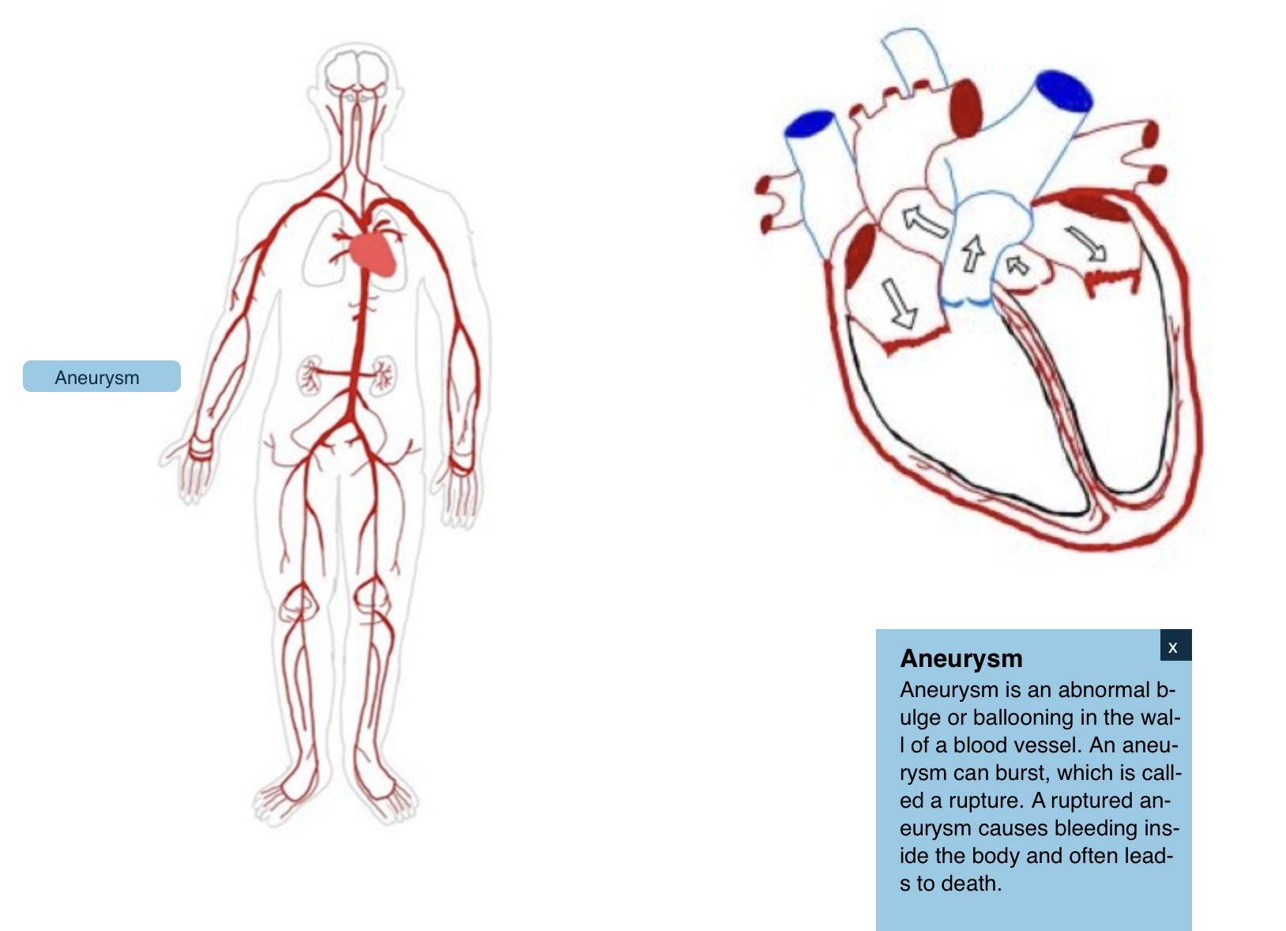
Visualization 2- Heart Disease Mortality Rate By State

This visualization uses a bar chart to show the heart disease mortality rate of each state in the US. By moving the slider, we can select the year from 2014 to 2021. In this interactive visualization, we can observe the change of mortality rate in different years and also find the difference between states.
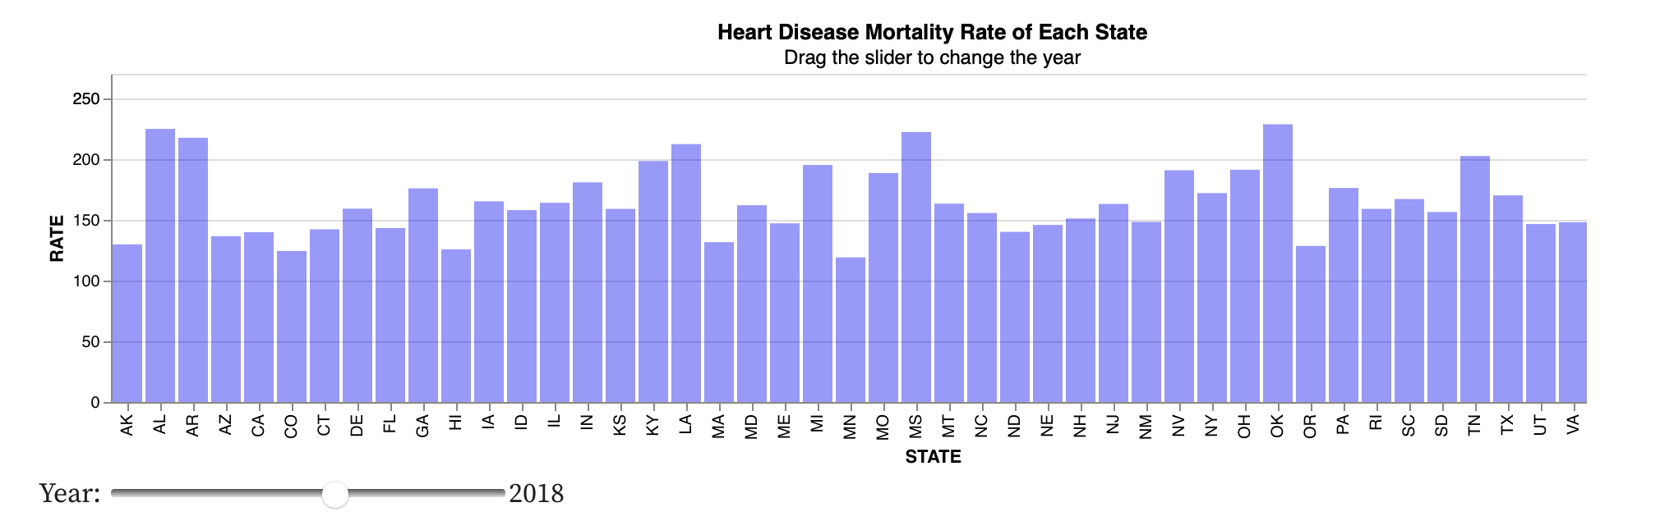

Visualization 3- Heart Disease Mortality Number By State in 2021

This visualization uses a scatter plot to show the heart disease mortality number of each state in the US. By selecting the menu, we can see the state in a certain range of death numbers. For example, if we choose 10000, it will show all the states with 5000 to 10000 deaths in 2021. It is easier for us to find the states with similar ranges of mortality numbers and make a comparison.
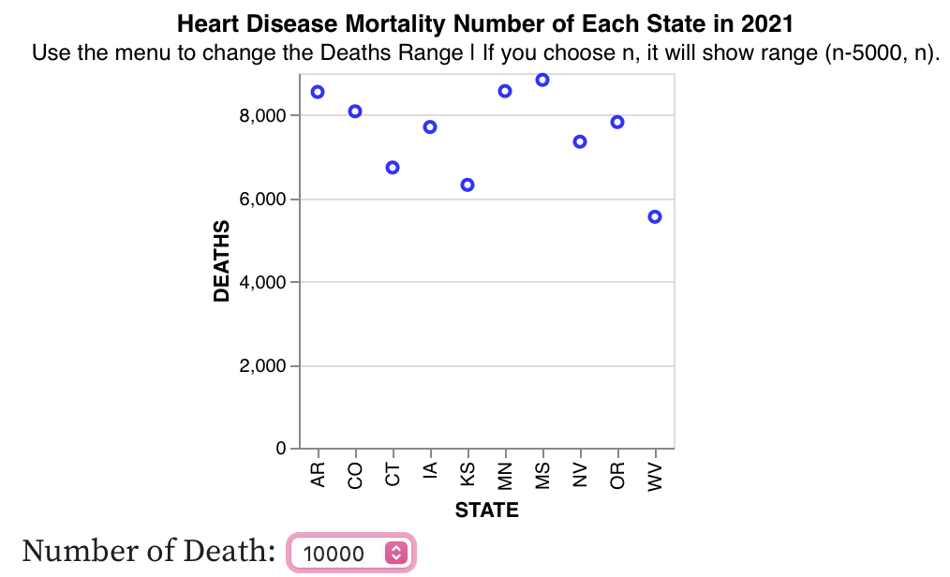

Visualization 4- US Heart Disease Mortality By States in 2005

In this visualization, we use a map to show the heart disease mortality of different states. We utilize a color bar to represent the rates. If our mouse stops by a state for a while, it will show the actual rates of this state in a small window.
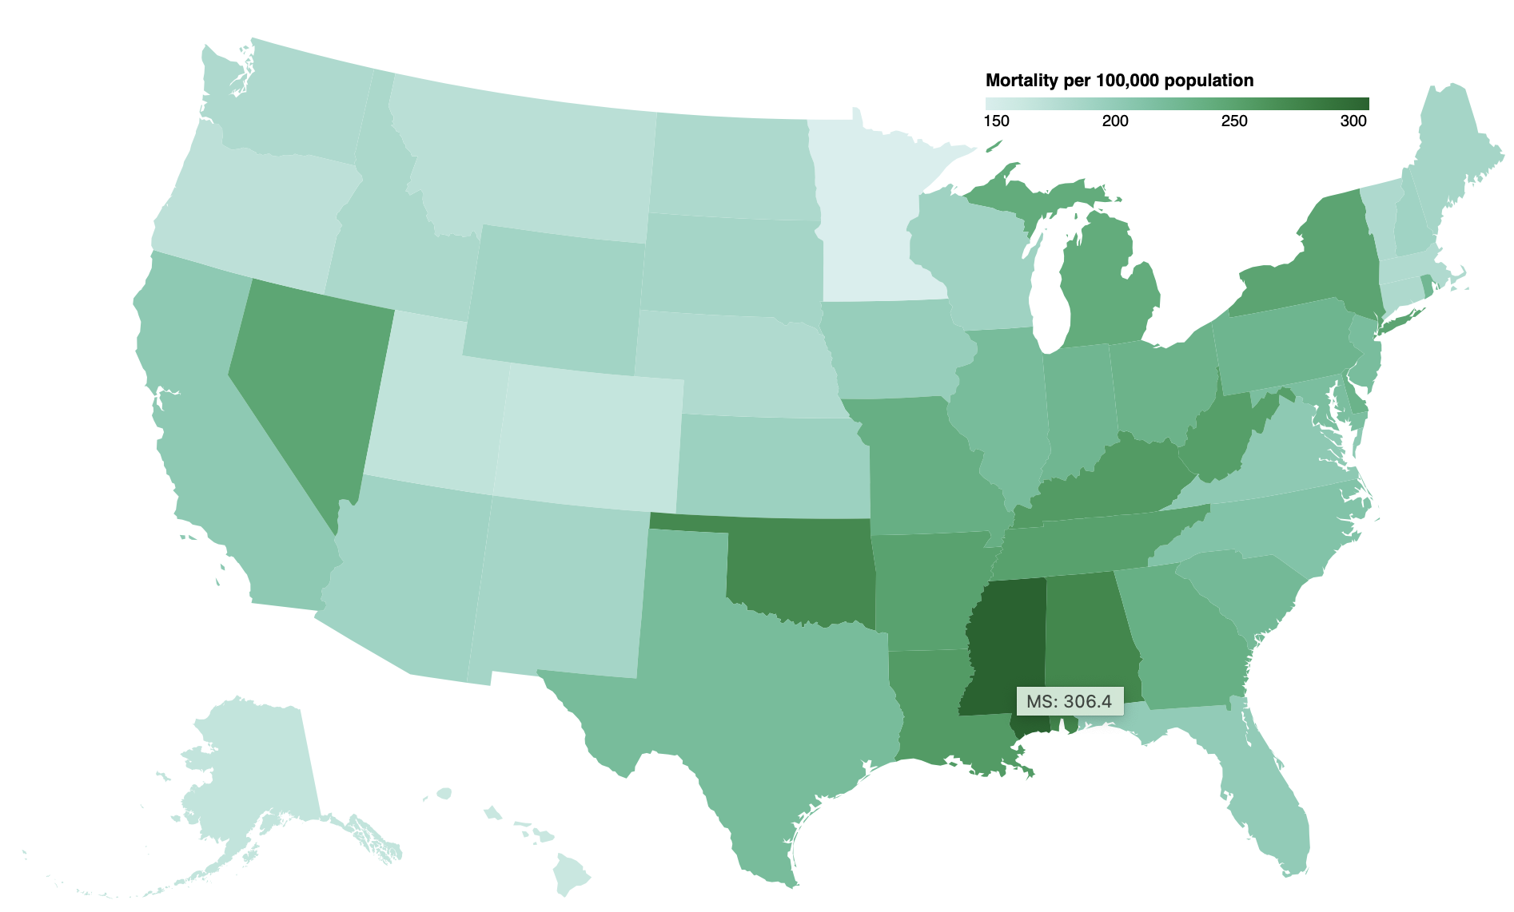

Visualization 5- US Heart Disease Mortality By Gender in 2019

This visualization shows heart disease mortality by gender in different states in 2019. We can use the menu to select the specific state we want to observe. By this figure, we can see if there are different distributions of mortality rate between males and females in different states.

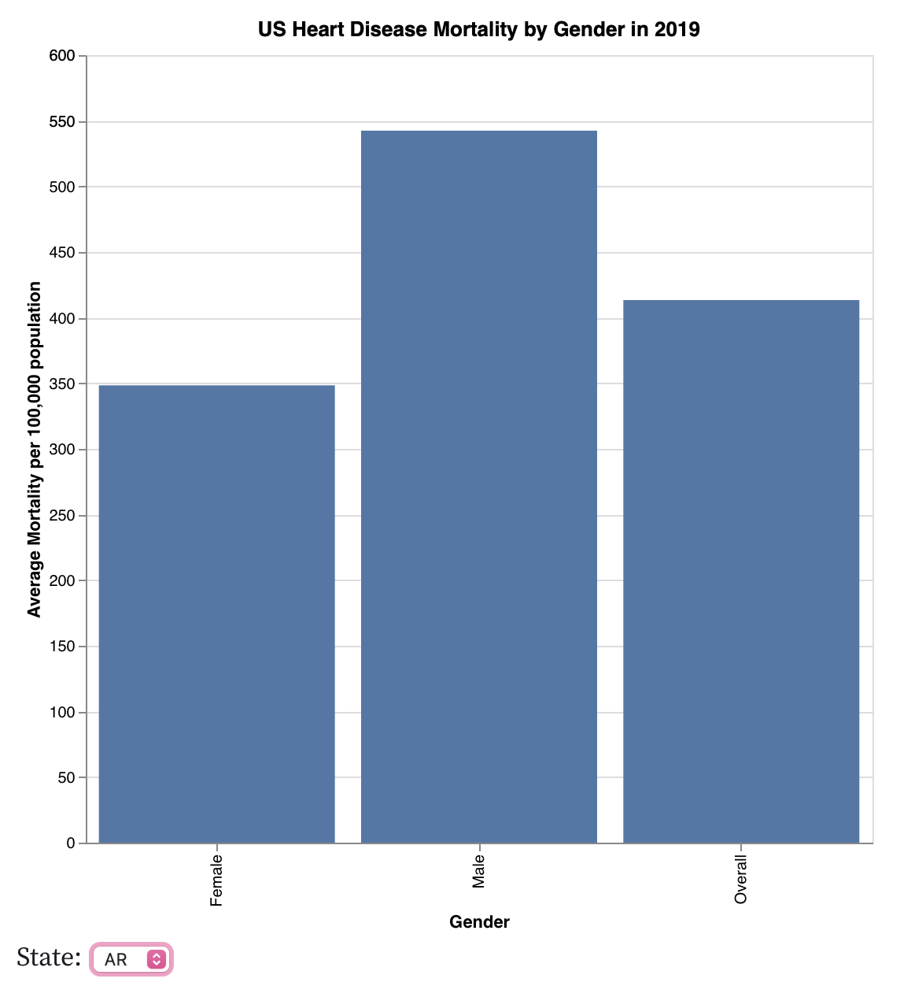

Reflections
In the initial idea of the project, we aimed to find datasets for different circulatory system diseases and incorporate them into a visualization of the human body. Unfortunately, very few reputable resources, such as those from the US government or other reliable organizations, provide separate datasets for individual diseases within the circulatory system. The majority of available datasets only offer overall information under a broad category like "heart diseases." Additionally, even when we manage to find some resources, the datasets are often messy and challenging to integrate into a cohesive visualization format.

As a result, we've adjusted our approach to only include brief introductions to each disease (text information) within the human-body interactive visualization. By complementing this with additional interactive graphs such as bar charts, scatter plots, and choropleth maps, we can still convey several related pieces of information to viewers and raise awareness about heart disease.

